Problem1: F(a,b,c) = ∑m(3, 4, 6, 7)

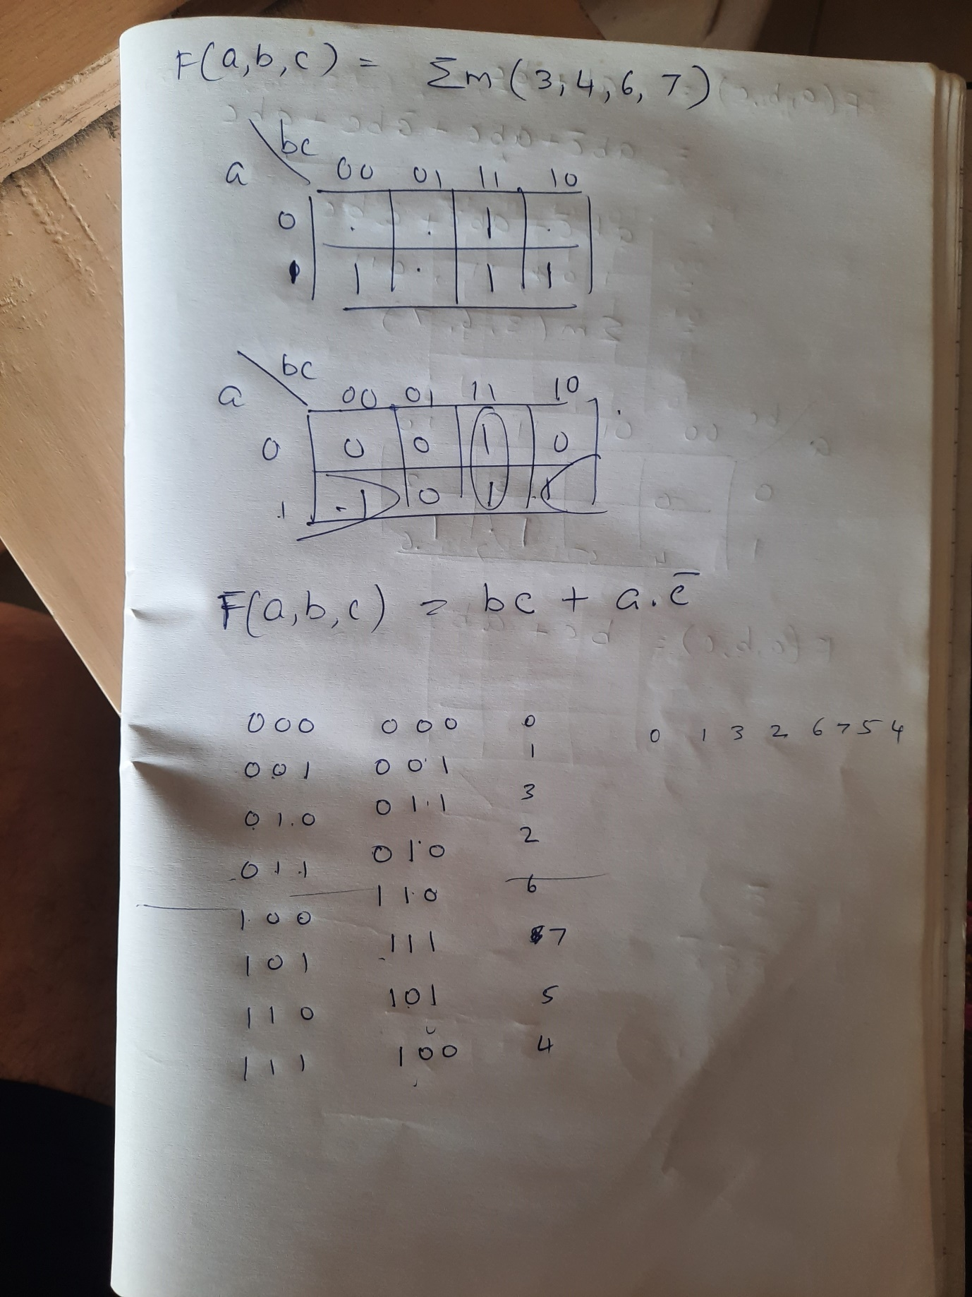

Problem2: F(a,b,c,d) = ∑m(5, 6, 7, 13, 14, 15)

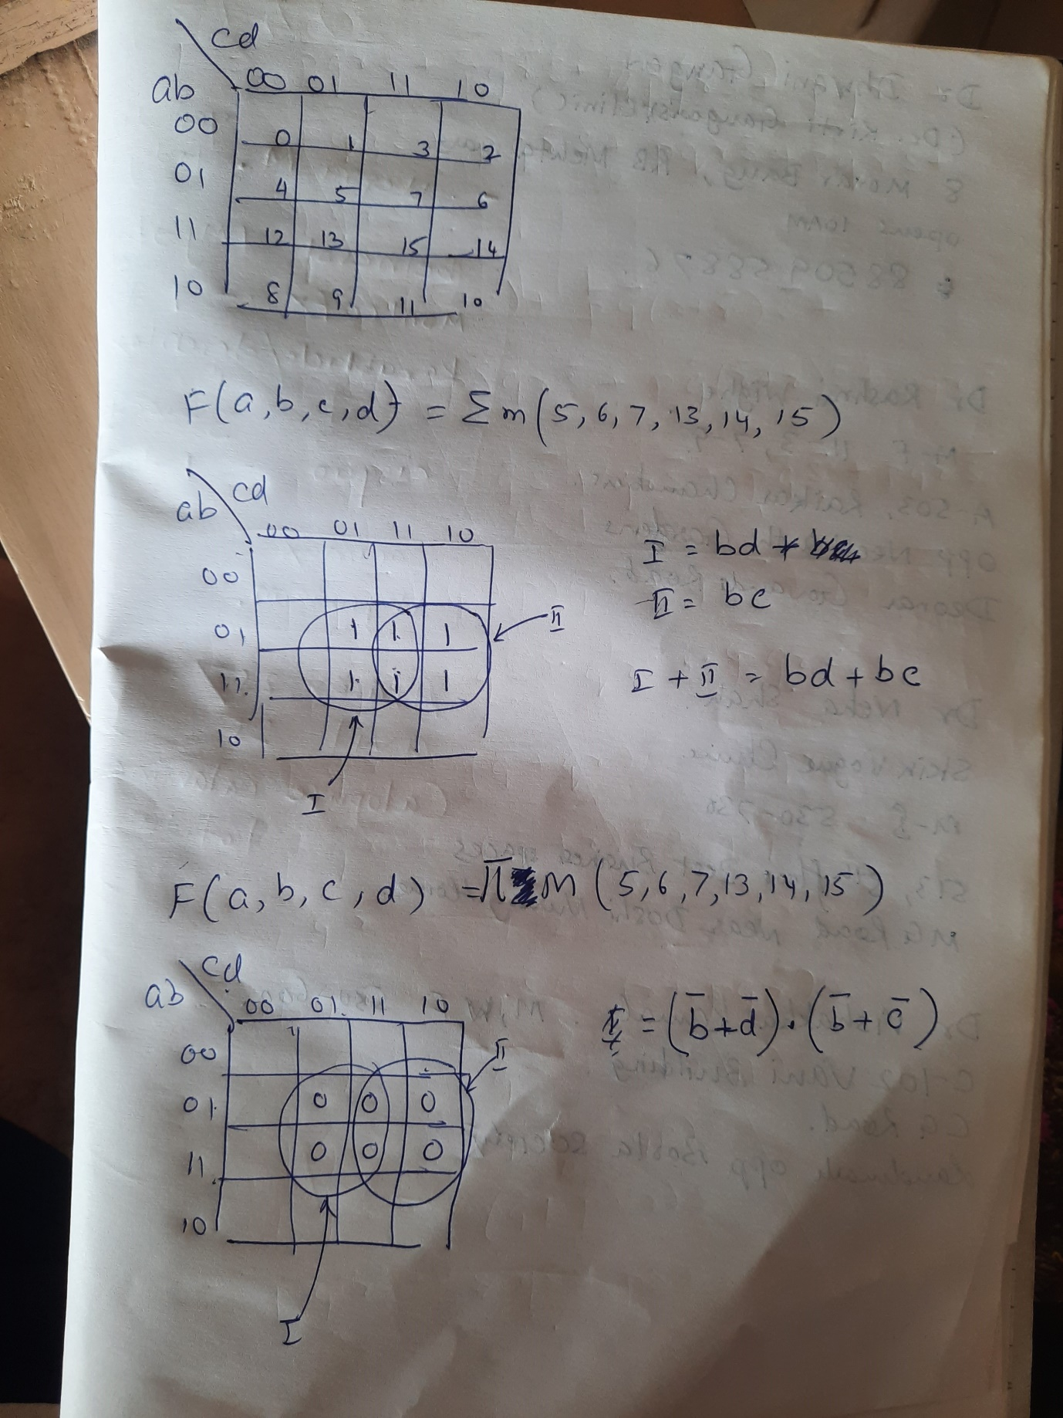

Problem3: F(p, q, r, s) = m0, m1, m2, m4, m6, m8, m10, m12, m14

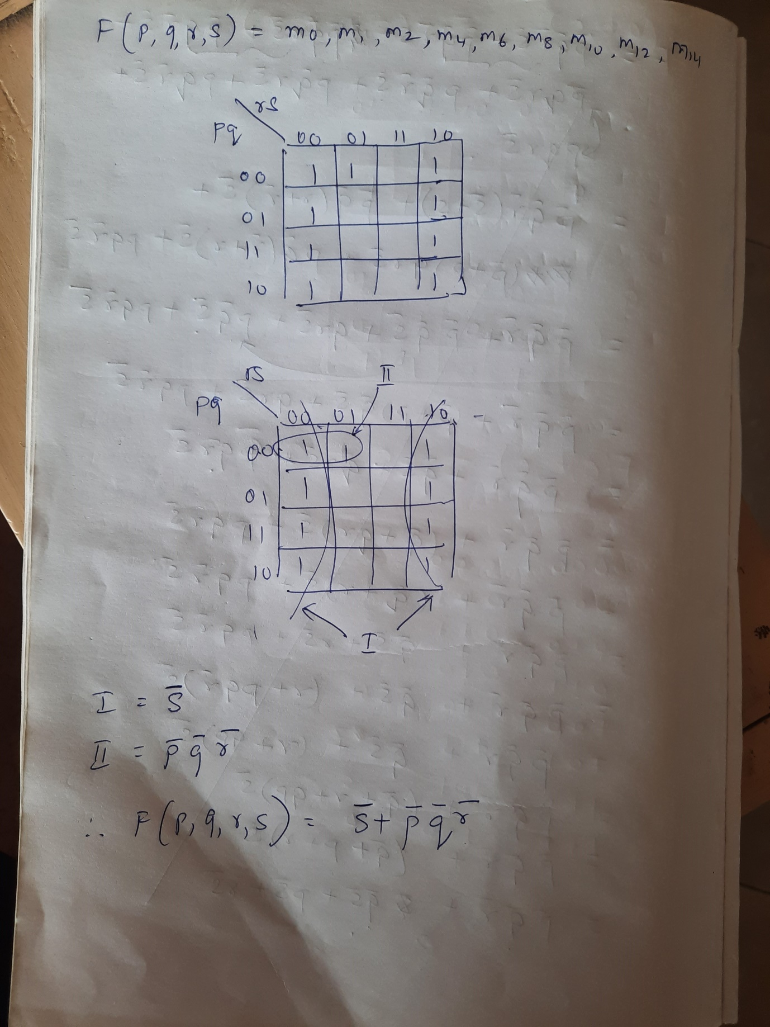

Don’t Care (X) Conditions in K-Maps

